
In Classcraft, players have a character class, experience points (XP), hit points (HP), action points (AP) and power points (PP).
LEVELING UP
A player gains experience points when he accomplishes certain tasks. Examples of such tasks are listed in the table below:

For every 1000 XP
points a player gains, he will level up and gain 1 PP, which he will be able to spend to buy powers. The cost of these powers is listed on the attached power trees.

BEHAVIOUR | XP
Finding a mistake in the class notes | 50
Per point above a 70% score on a test | 20
Correctly answering a question in class | 60
Helping another student with their classwork | 75
Helping another player by using your powers | 5 AP
Being positive and hard working in class | 100
LIFE
Nothing
Saturday-morning detention
Copying a text
10 min less to complete the next exam
5 min less to complete the next exam
1 day less to hand in the following paper
BEHAVIOUR | HP
Arriving late to class | 10
Disturbing the class | 5
Arguing with the Gamemaster | 10
Being negative, lacking motivation or slacking off in class | 20
Incomplete homework | 30
Per point below a 60% score on a test | 5
A player loses HP if he fails to accomplish certain tasks. Examples of such tasks are listed in the table below:

Players can only regain HP by using powers, but automatically gain 4 AP per day.

… AND DEATH
When a player runs out of HP, he can be revived by a Healer. Failure to do so results in death. The player must then roll the Death Die and suffer the penalty shown on the die. The possible penalties are:

The player will then come back to life with 1 HP. When a player dies, all the players in his team suffer 10 damage to their HP. A player who dies and triggers this team penalty does not make his team suffer this again.

MAGE POWER TREE
MAX HP: 30 / MAX AP: 50
POWER | TIER  (PP) | ACTION  POINTS | DESCRIPTION | PRE-REQUISITE POWERS
Mana Transfer | 1 | 35 | All of the team members, except Mages, gain 7 AP
Teleport | 1 | 5 | The Mage can leave the classroom for up to 2 minutes
Invisibility | 1 | 10 | The Mage can be late for class (maximum 2 minutes)
Mana Shield | 2 | 3 x Damage | The Mage can transfer damage to his AP at a cost of 3 AP per HP prevented | Mana Transfer
Cheat Death | 2 | 15 | A dead teammate (other than the Mage) can reroll the death die, but must accept the new outcome | Teleport
Time Warp | 2 | 35 | The Mage gains an extra 8 minutes to beat an exam | Teleport and Invisibility
Fountain of Mana | 3 | 40 | A teammate, who isn’t a Mage, replenishes all of his AP | Mana Shield
Clairvoyance | 3 | 40 | All of the team members get a hint on an exam question | Cheat Death and Mana Shield
Mage Circle | 3 | 80  (40 x 2) | When two Mages use this power at the same time, all of the team members gain an extra 8 minutes to beat an exam | Time Warp

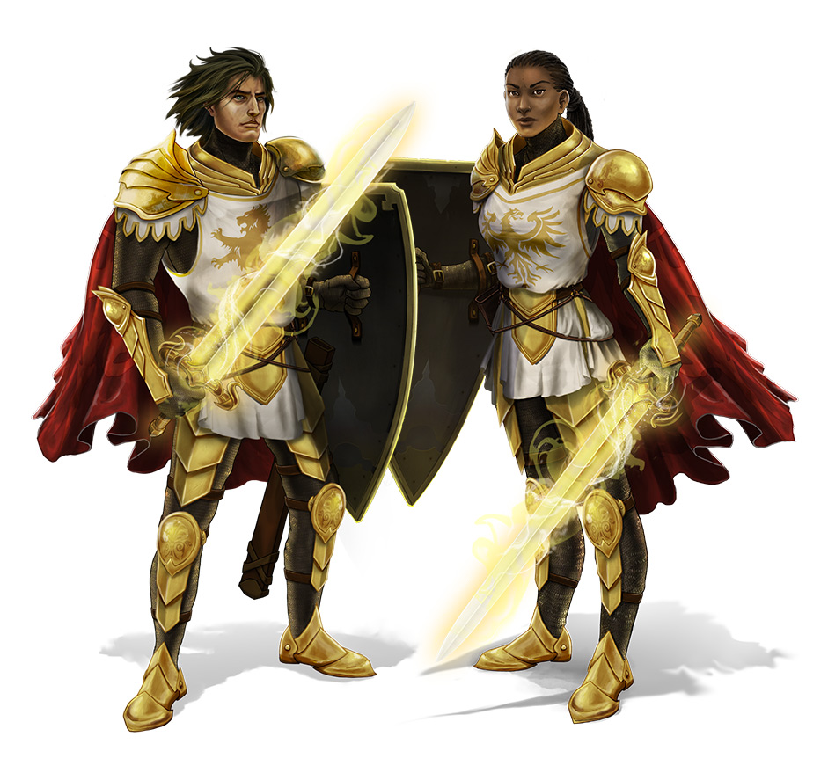
WARRIOR POWER TREE
MAX HP: 80 / MAX AP: 30

POWER | TIER  (PP) | ACTION  POINTS | DESCRIPTION | PRE-REQUISITE POWERS
Protect 1 | 1 | 10 | The Warrior can take up to 10 damage instead of his teammate, receiving only 80% of the initial damage
First Aid | 1 | 10 | The Warrior gains 1 HP/level, for a maximum of 5 HP
Hunting | 1 | 5 | The Warrior can eat in class
Protect 2 | 2 | 15 | The Warrior can take up to 20 damage instead of his teammate, receiving only 65% of the initial damage | Protect 1
Ambush | 2 | 20 | The Warrior can hand in an assignment one day later | Protect 1 and First Aid
Counter Attack | 2 | 20 | The Warrior gets a hint on an exam question | Hunting
Protect 3 | 3 | 20 | The Warrior can take up to 30 damage instead of his teammate, receiving only 50% of the initial damage | Protect 2
Frontal Assault | 3 | 60  (30 x 2) | When two Warriors use this power at the same time, all of the team members can hand in an assignment one day later | Counter Attack
Secret Weapon | 3 | 25 | During an exam, the Warrior can use a cheat sheet provided by the Gamemaster | Ambush and Counter Attack


HEALER POWER TREE
MAX HP: 50 / MAX AP: 35

POWER | TIER  (PP) | ACTION  POINTS | DESCRIPTION | PRE-REQUISITE POWERS
Heal 1 | 1 | 15 | A teammate gains 10 HP
Sainthood | 1 | 5 | The Healer can open or close a window
Ardent Faith | 1 | 10 | During an exam, the Healer can ask the Gamemaster if his answer to a question is right
Heal 2 | 2 | 20 | A teammate gains 20 HP | Heal 1
Favor of the Gods | 2 | 20 | The Healer can listen to his iPod during classwork | Sainthood
Revive | 2 | 25 | When a teammate (not including the Healer) falls to 0 HP, he avoids all penalties and comes back to life with 1 HP | Ardent Faith
Heal 3 | 3 | 20 | A teammate gains 30 HP | Heal 2
Healing Circle | 3 | 30 | All of the team members gain 15 HP | Heal 2
Prayer | 3 | 30 | During an exam, the healer has access to his notes | Revive and Favor of the Gods

EVENTS
Every class, a random event occurs. These events can be beneficial, funny, harmful or simply chaotic. However, everyone, including the game master, must submit to them. The list of random events is very long as there are many possibilities. Here is a partial list:

Healing You find a small first aid kid Everyone gains 5 HP
Poison You eat poisoned food Everyone loses 5 HP
Training You train extra hard to get strong Everyone gains double XP today
Feeble You forget to train and feel weak Everyone loses double HP today
Empathy A strange man helps the feeble The player in each team with the
least XP gains 150 XP

